**[Classification c1,] "*O*utside cOver reuse"**

<DisplayName> **Outside cOver reuse** </DisplayName>

<KeyboardShortcut> **O** </KeyboardShortcut>

<DirectoryName> **Outside_Cover_Reuse** </DirectoryName>

<AddedFilenameEnding> **orc** </AddedFilenameEnding>

Front cover, back cover, spine, all three. The text/decoration/illumination is visible on the outside cover surface is visible through from the other side. It must be on the codex/book. Limp vellum covers OK, but not wrappers.

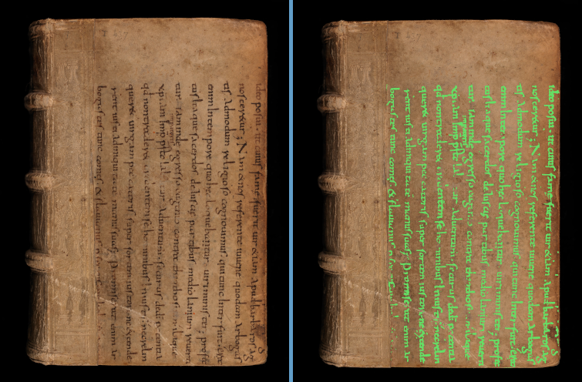

BaselUniversitatsbib_-_Le-VI-12_00001

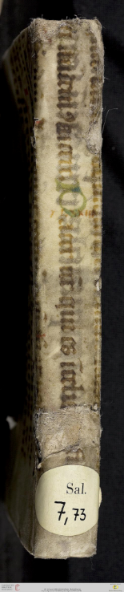

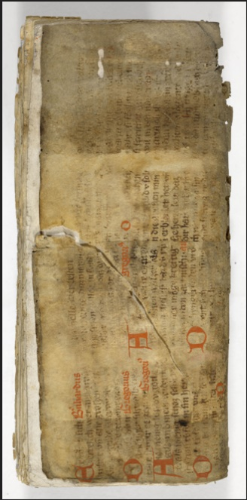

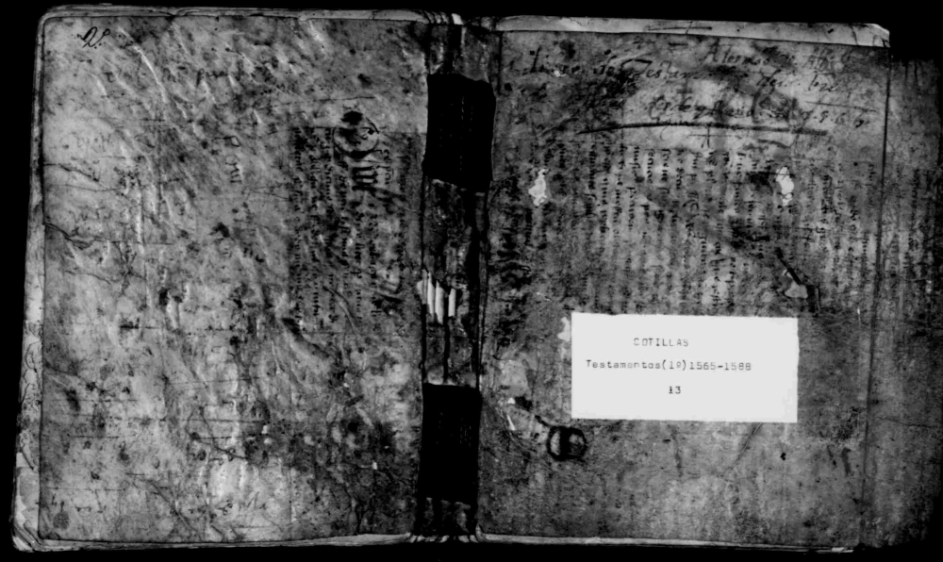

Heidelberg_-_

salVII73__

z4_00249

FamilySearch_-_DGS004090639_00701

Ba,berg+=+JV<Msc359_00073

**[Classification c2,] "unde*R* coveR Reuse"**

<DisplayName> **undeR coveR Reuse** </DisplayName>

<KeyboardShortcut> **R** </KeyboardShortcut>

<DirectoryName> **Under_Cover_Reuse** </DirectoryName>

<AddedFilenameEnding> **ucr** </AddedFilenameEnding>

A tear or hole reveals some reuse under the cover or under the paste-down. If it can be determined that this is really reuse protecting the spine, use 's**P**ine Protection reuse'. It is okay to use both of those *for the same piece of reuse*, as long as you DON’T use 'multiple **B**inding reuse classes'. However, if there is such an unsure piece as well as *another* instance of reuse, *do* use 'multiple **B**inding reuse classes' along with the classification(s) of the other class(es).

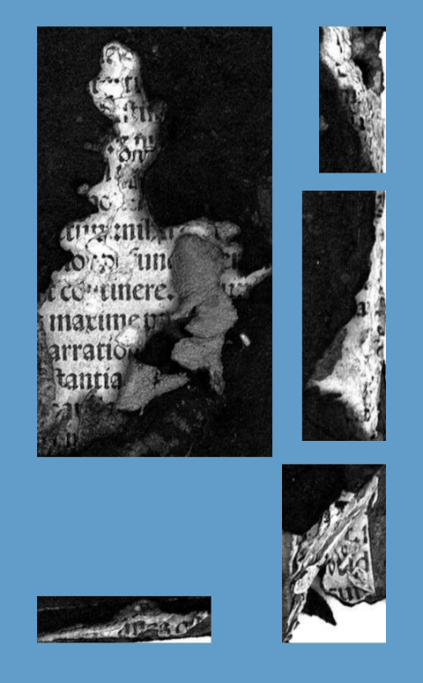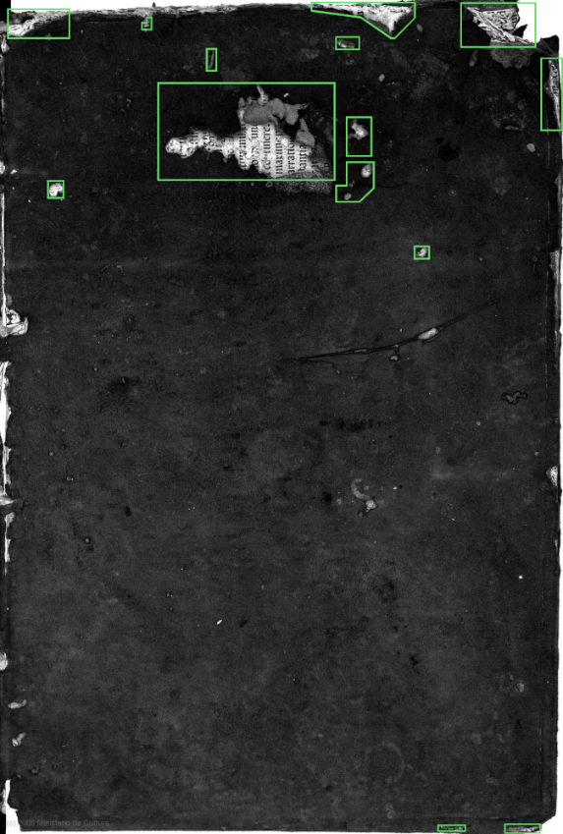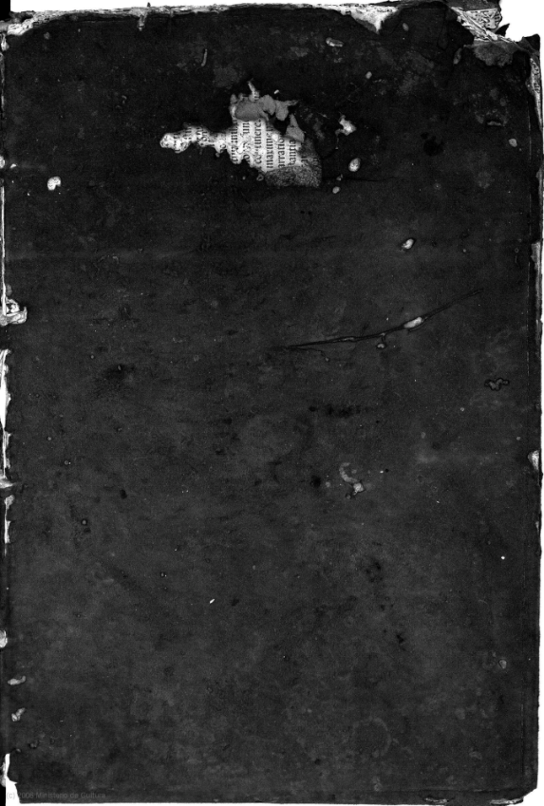

BVPG_-_BibCastillaLaMancha_-_MarcoAurelio_BPE-Toledo-Signatura-16356_00001

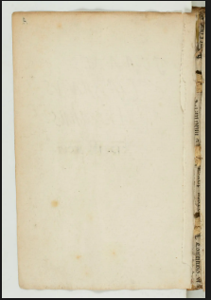

BnF_-_Latin11399_00004

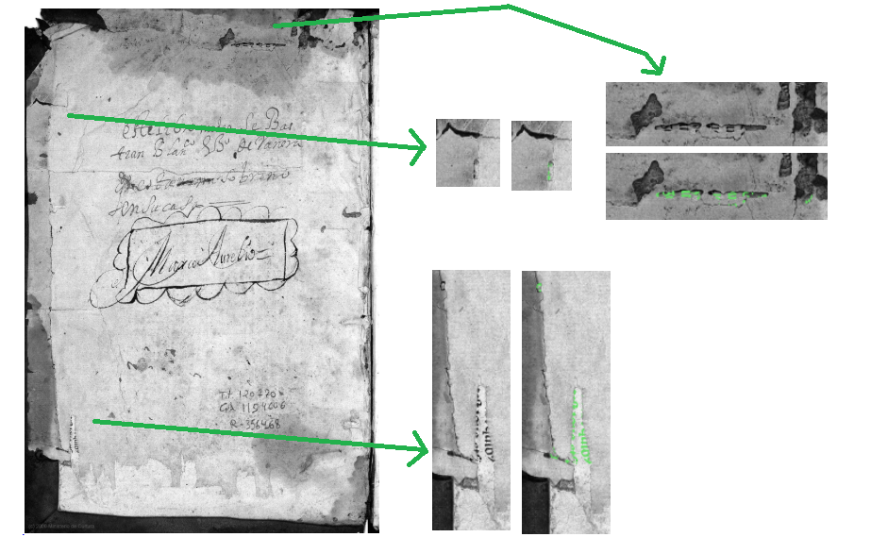

BVPG_-_BibCastillaLaMancha_-_MarcoAurelio_BPE-Toledo-Signatura-16356_00002

**[Classification c3,] "s*P*ine Protection reuse"**

<DisplayName> **sPine Protection reuse** </DisplayName>

<KeyboardShortcut> **P** </KeyboardShortcut>

<DirectoryName> **Spine_Protection_Reuse** </DirectoryName>

<AddedFilenameEnding> **spr** </AddedFilenameEnding>

A fragment is reused to protect the spine. In some cases, it also goes around to protect part of the covers; however, if it can be seen as part of a paste-down or flyleaf, do not classify it as 'sPine Protection reuse' *unless* the image of the surface is meant specifically to show the spine. If it can be seen as part of a paste-down or flyleaf and is not part of a spine image, it should be labeled 'Front-back matter reuse'.

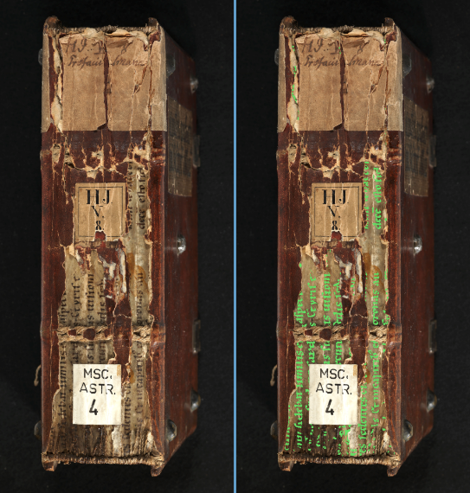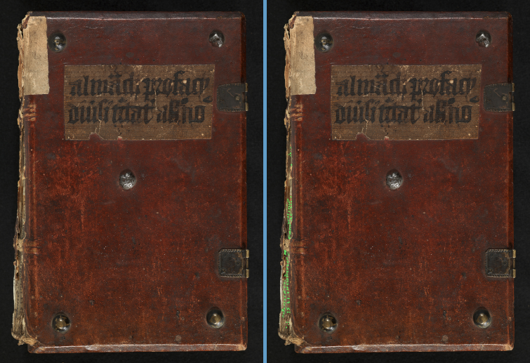*Note that these first two surface views are two different views of the same codex.*

Bamberg_-_MscAst4_00002

Bamberg_-_MscAst4_00438

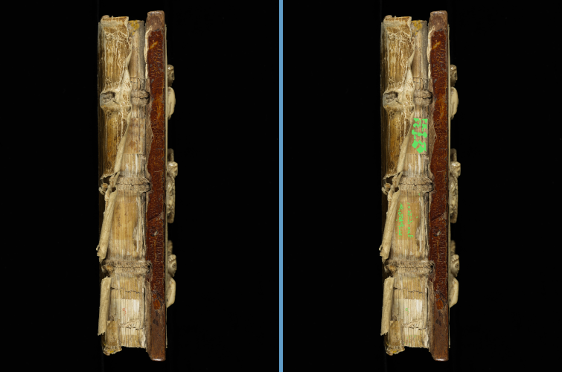

BeromunsterStiftskircheStMichael_-_Epistolar-ecod_028

f

f

font